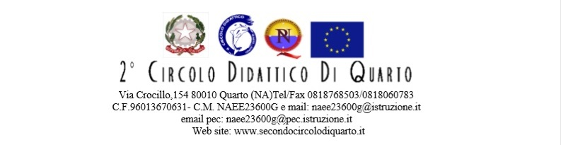

Relazione finale progetto P.O.F.T.: ___________________________________

Prof. Referente:__________________________
Prof. Docente :__________________________
Prof. Tutor :__________________________

Attività svolte:
__________________________________________________________________________________________________________________________________________________________________________________________________________________________________________________________________________________________________________________________________________________________________________________________________________________________________________________________________________________________________________________________________________________________________________________________________________________________________________________________________________________________________________________________________________________________________________________________________________________________________________________________________________________________________________________________________________________________________________________________________________________________________________________________________________________________________________

Risultati in termini di competenze acquisite: gli allievi hanno acquisito i seguenti obiettivi:

Formativi:
__________________________________________________________________________________________________________________________________________________________________________________________________________________________________________________________________________________________________________________________________________________________________________________________________________________________

Conoscitivi:
__________________________________________________________________________________________________________________________________________________________________________________________________________________________________________________________________________________________________________________________________________________________________________________________________________________________

Operativi:
________________________________________________________________________________________________________________________________________________________________________________________________________________________________________________________________________________________________________________________________________
__________________________________________________________________________________

N. iscritti | N. partecipanti
Coinvolgimento dei corsisti
 | n. alunni
poco
sufficiente
molto

Considerazioni finali (in particolare motivare l’opportunità di programmare il corso per l’anno 20__/20__) :
______________________________________________________________________________________________________________________________________________________________________________________________________________________________________________________
Punti di forza:
______________________________________________________________________________________________________________________________________________________________________________________________________________________________________________________
Punti di debolezza:
__________________________________________________________________________________
____________________________________________________________________________________________________________________________________________________________________
Eventuali suggerimenti e modifiche da proporre: ____________________________________________________________________________________________________________________________________________________________________
__________________________________________________________________________________
Analisi del monitoraggio in itinere:
Grado di soddisfazione:
______________________________________________________________________________________________________________________________________________________________________________________________________________________________________________________
Efficacia del corso:
______________________________________________________________________________________________________________________________________________________________________________________________________________________________________________________

Analisi del monitoraggio finale:
Grado di soddisfazione:
______________________________________________________________________________________________________________________________________________________________________________________________________________________________________________________
Efficacia del corso:
______________________________________________________________________________________________________________________________________________________________________________________________________________________________________________________Quarto, ____________________
Firme
_________________________
_________________________
_________________________

